**NAME – Anuj Bohra Assignment - Operating System**

**Roll no. 233014**

#!/bin/bash

echo -e "chose 1.Addition\n 2.Subtraction\n 3.Multiplication\n 4.Division" read -p "operation to execute" o

read -p "Enter two numbers" n1 read n2

case $o in

"1")

;; "2")

;; "3")

;;

"4")

;;

echo "addition is:" expr $n1 + $n2

echo "subtraction is:" expr $n1 - $n2

echo "multiplication is:" expr $n1 \* $n2

echo "division is:" expr $n1 / $n2

esac

*) echo "deflt"

;;

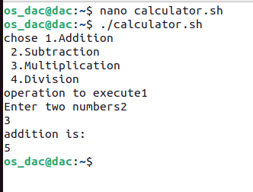

2.

#!/bin/bash

read -p "Enter three numbers" n1 read n2

read n3

if [ $n1 -gt $n2 ] && [ $n1 -gt $n3 ] then

echo "$n1 is greatest number"

elif [ $n2 -gt $n1 ] && [ $n2 -gt $n3 ] then

echo "$n2 is greatest no"

else

echo "$n3 is greatest no"

fi

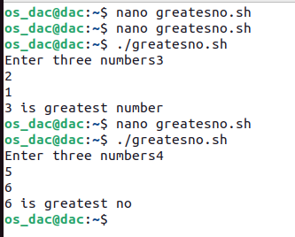

3.

#!/bin/bash

read -p" Enter the number to create file" n for((i=0;i<n;i++))

do

touch $i.txt

done

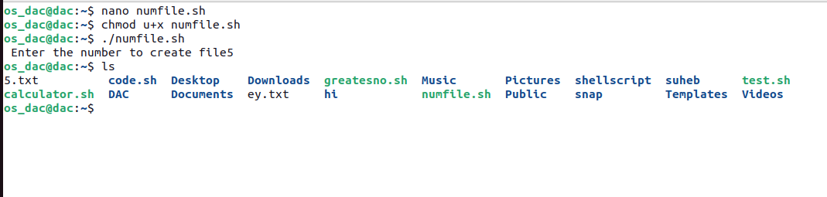

4.

#!/bin/bash

read -p "enter the number to check if it is even or odd" n even=`expr $n % 2 `

if [ $even -eq 0 ] then

else fi

echo "$n is an even number" echo "$n is an odd number"

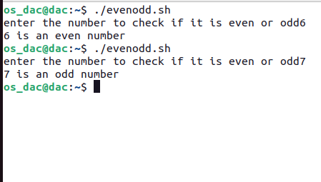

5.

#!/bin/bash

read -p "enter any natural number:" n sum=0

for((i=1;i<=n;i++)) do

echo "$i"

done

for((i=1;i<=n;i++)) do

done

sum=$((sum+i)) echo $sum

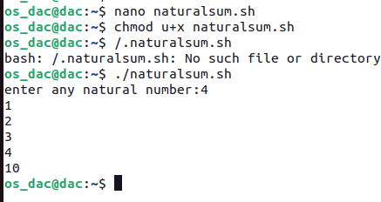

6.

#!/bin/bash

for((i=0;i<10;i++)) do

read a[$i]

done sum=0

for((i=0;i<10;i++)) do

sum=$((sum+a[$i]))

done

echo "sum: $sum"

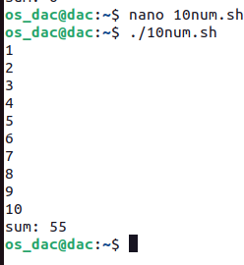

# Write a Shell Script to display the cube of the number up to an integer.

#!/bin/bash

read -p "Enter the number of terms" n for((i=1;i<=n;i++))

do

echo "number is :" $i cube=$(($i*$i*$i))

echo "its cube is:" $cube

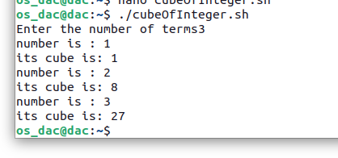done

# Write a Shell Script to display the multiplication table for a given integer.

#!/bin/bash

read -p "enter the number" n for((i=1;i<=10;i++))

do

t=$(($n*$i))

echo "$n*$i=" $t

done

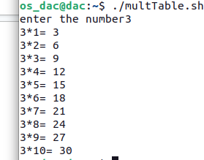

**7.**

#1/bin/bash

read -p "enter the number" n

for((i=1;i<=n;i++))

do

for((j=1;j<=10;j++))

do

echo -n "$i x $j = $((i*j)), "

done

echo -e "\n"

done

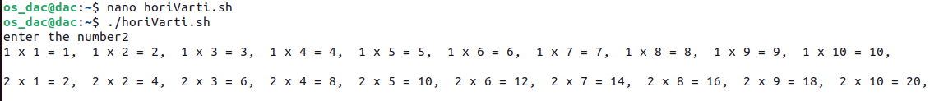

**8.**

#1/bin/bash

read -p "Enter the number" n

sum=0

echo "Odd no are: "

for((i=1;i<=2*n;i++))

do

if(($i%2!=0))

then

echo $i

sum=$((sum+i))

fi

done

echo "Sum:$sum"

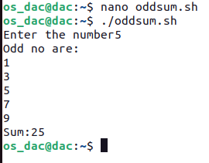

**9**

#!/bin/bash

for((i=0;i<5;i++))

do

for((j=0;j<i;j++))

do

echo -n "*"

done

echo ""

done

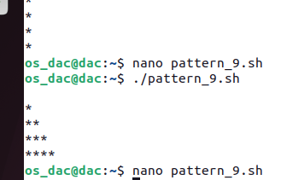

10.

#!/bin/bash

for((i=1;i<=4;i++))

do

for((j=1;j<=i;j++))

do

echo -n "$j"

done

echo ""

done

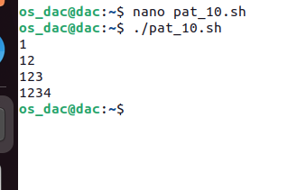

**11.**

#!/bin/bash

for((i=1;i<=4;i++))

do

for((j=1;j<=i;j++))

do

echo -n "$i"

done

echo""

done

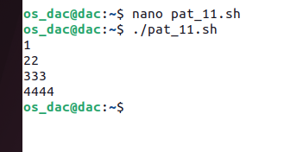

**12.**

#!/bin/bash

n=1

for((i=1;i<=4;i++))

do

for((j=1;j<=i;j++))

do

echo -n "$n"

((n=n+1))

done

echo""

done

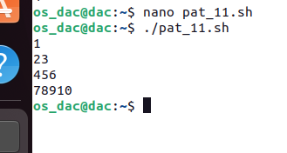

**13.**

#!/bin/bash

n=1

for((i=0;i<4;i++))

do

for((j=1;j<=4-i;j++))

do

echo -n " "

done

for((j=1;j<=i+1;j++))

do

echo -n "$n "

((n=n+1))

done

echo

done

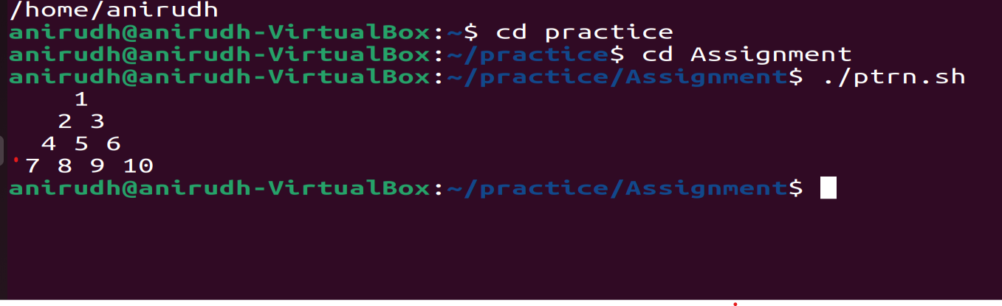

**14.**

**#!/bin/bash**

**for((i=1;i<=5;i++))**

**do**

**for((j=1;j<=5 - i;j++))**

**do**

**echo -n " "**

**done**

**for((j=1;j<=2*i - 1;j++))**

**do**

**echo -n "* "**

**done**

**echo**

**done**

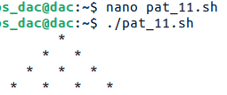

**15.**

#!/bin/bash

read -p "Enter the number to calculate factorial" n

fact=1

for((i=1;i<=n;i++))

do

fact=$((fact*i))

done

echo "factorial of number $n is $fact"

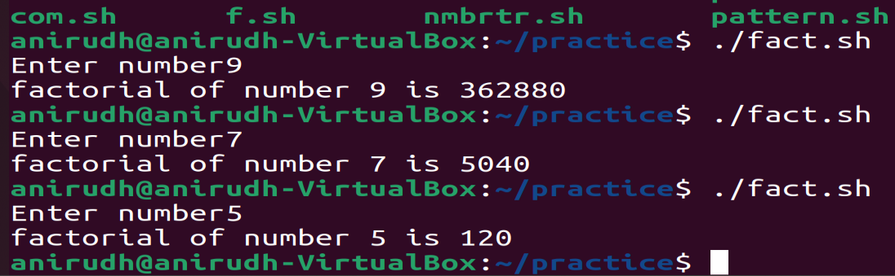

16.

#!/bin/bash

read -p "Enter the number " n

sum=0

for((i=1;i<2*n+1;i++))

do

if(($i%2==0))

then

echo "Even numbers are : $i"

sum=$((sum+i))

fi

done

echo "Sum of even numbers are $sum "

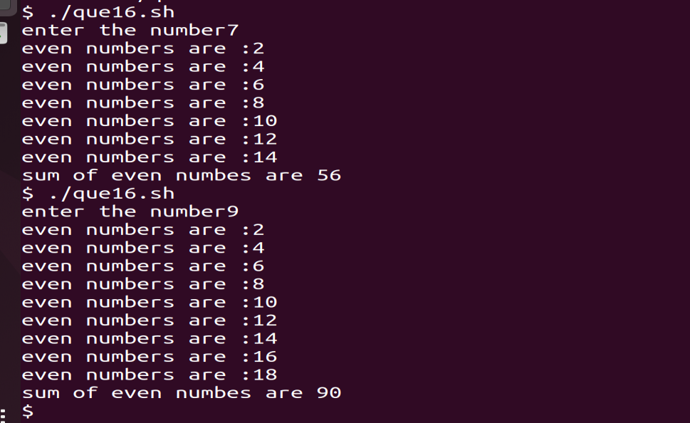

**17.**

#!/bin/bash

for((i=0;i<4;i++))

do

for((j=1;j<=4-i;j++))

do

echo -n " "

done

for((j=1;j<=i+1;j++))

do

echo -n "$((i+1)) "

done

echo

done

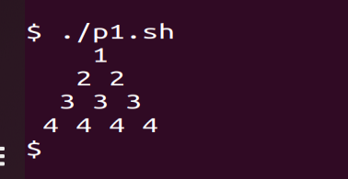

18.

#!/bin/bash

echo "Enter the value of X: "

read x

# Initialize variables

sum=1

fact=1

sign=-1

# Loop to calculate the sum

for (( i=2; i<=10; i+=2 ))

do

fact=$((fact*i*(i-1)))

term=$(echo "$x^$i/$fact" | bc -l)

term=$(echo "$term*$sign" | bc -l)

sum=$(echo "$sum+$term" | bc -l)

sign=$((sign*(-1)))

done

# Print the result

echo "Sum of the series [1 - X^2/2! + X^4/4! - ...] for X=$x is: $sum"

**19.**

#!/bin/bash

read -p "enter number" n

sum=0

for((i=1;i<=n;i++))

do

term=$(echo "1/$i" | bc -l)

sum=$(echo "$sum+$term" |bc -l)

done

echo $sum

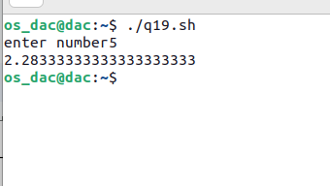

**20.**

#1/bin/bash

for((i=1;i<=3;i++))

do

for((j=3-i;j>=0;j--))

do

echo -n " "

done

for((k=1;k<=2*i-1;k++))

do

echo -n "*"

done

echo

done

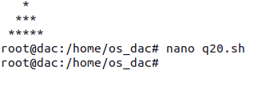

**21.**

#!/bin/bash

read -p "Enter the number: " n

t=9

sum=0

for((i=0;i<n;i++))

do

sum=$((sum+t))

echo -n "$t "

t=$((t*10+9))

done

echo "sum="$sum

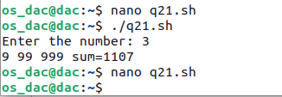

**22.**

#!/bin/bash

n=1

for((i=1;i<=5;i++))

do

for((j=1;j<=i;j++))

do

if((n%2==0))

then

echo -n "0"

else

echo -n "1"

fi

n=$((n+1))

done

echo

done

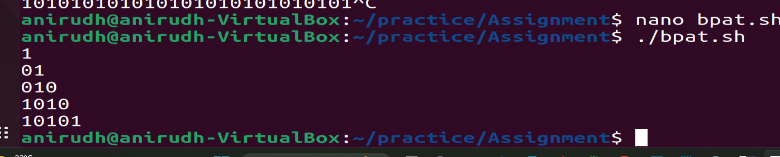

**23.**

#!/bin/bash

read -p "Enter the value of x : " x

read -p "Enter the value of n :" n

sum=0

sign=1

power=1

for((i=1;i<=n;i++))

do

term=$(echo "$x^$power*$sign" |bc -l)

sum=$(echo "$sum+$term" | bc -l)

power=$(echo "$power+2" | bc -l)

sign=$(echo "$sign*-1" | bc -l)

done

echo $sum

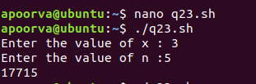

**24.**

#!/bin/bash

read -p "Enter the value of x : " x

read -p "Enter the value of n :" n

sum=0

sign=1

power=1

for((i=1;i<=n;i++))

do

term=$(echo "$x^$power*$sign" |bc -l)

sum=$(echo "$sum+$term" | bc -l)

power=$(echo "$power+2" | bc -l)

sign=$(echo "$sign*-1" | bc -l)

done

echo $sum

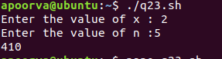

**25.**

!/bin/bash

read -p "enter the number" n

sum=0

a=0

for((i=1;i<=n;i++))

do

a=$((i*i))

echo -n $a" "

sum=$((sum+a))

done

echo " "

echo "sum" $sum

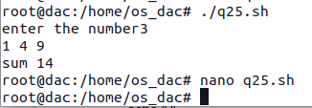

**26.**

#!/bin/bash

read -p "enter the number" n

temp=1

sum=0

for((i=1;i<=n;i++))

do

echo -n $temp "+"

sum=$((sum+temp))

temp=$(($temp*10+1))

done

echo

echo "sum: "$sum

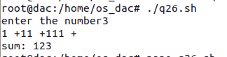

**27.**

#!/bin/bash

read -p "enter the numbwer" n

for((i=1;i<=n-1;i++))

do

if(($n%$i==0))

then

echo -n $i" "

sum=$((sum+i))

fi

done

echo

echo "sum: "$sum

if(($sum==$n))

then

echo "number is perfect number"

else

echo "number is not a perfect number"

fi

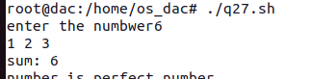

**28.**

#!/bin/bash

read -p "Enter the value of n : " n

for((i=2;i<n;i++))

do

for((j=1;j<i;j++))

do

if(($i%$j==0))

then

sum=$((sum+j))

fi

done

if(($i==$sum))

then

echo -n "$i "

fi

sum=0

done



**29.**

#!/bin/bash

read -p "Enter the number: " n

c=${#n}

for((i=0;i<n;i++))

do

digit=${n:i:1}

sum=$((sum+digit**c))

done

if(($sum==$n))

then

echo "$n is a Armstrong number "

else

echo "it is not an armstrong number"

fi



**30.**

#!/bin/bash

read -p "Enter the range from 1 to " n

for((i=1;i<n;i++))

do

c=${#i}

sum=0

for((j=0;j<i;j++))

do

digit=${i:j:1}

sum=$((sum+digit**c))

done

if(($sum==$i))

then

echo -n "$i"

fi

done

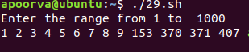

**31.**

#!/bin/bash

for((i=1;i<=5;i++))

do

for((j=6-i;j>0;j--))

do

echo -n " "

done

for((k=1;k<=2*i-1;k++))

do

echo -n "*"

done

echo

done

for((l=6;l<=9;l++))

do

for((m=1;m<=l-4;m++))

do

echo -n " "

done

for((n=19-2*l;n>0;n--))

do

echo -n "*"

done

echo

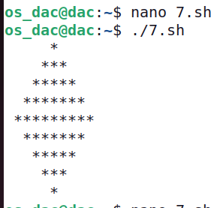

**32.**

#!/bin/bash

read -p "Enter the number : " n

for((i=1;i<=n;i++))

do

if(($n%$i==0))

then

c=$((c+1))

fi

done

if(($c<=2))

then

echo "$n is a prime number "

else

echo "it is not a prime number"

fi



1. Write a Shell Script to display Pascal's triangle. Test Data :

Input number of rows: 5 Expected Output :

1

1 1

1 2 1

1 3 3 1

1 4 6 4 1

#!/bin/bash

echo "Enter the number of rows: " read rows

# Function to calculate the factorial of a number function factorial() {

local num=$1 local fact=1

for((i=2;i<=num;i++)) do

fact=$((fact * i)) done

echo $fact

}

# Loop to calculate and print the elements of Pascal's triangle for ((i=0; i<rows; i++))

do

for ((j=0; j<=rows-i; j++)) do

echo -ne " "

# print spaces done

for ((j=0; j<=i; j++))

do

fact1=$(factorial $i) fact2=$(factorial $j) fact3=$(factorial $((i-j)))coefficient=$((fact1 / (fact2 * fact3))) echo -ne "$coefficient "

done

echo

# print a new line

done

**34.**

#!/bin/bash

read -p "Enter the range from 1 to " n

for((i=2;i<=n;i++))

do

c=0

for((j=1;j<=i;j++))

do

if(($i%$j==0))

then

c=$((c+1))

fi

done

if(($c<=2))

then

echo -n "$i "

fi

done

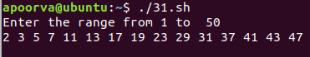

**35.**

#!/bin/bash

read -p "Enter the number : " n

a=0

b=1

for((i=0;i<n;i++))

do

echo -n "$a "

f=$((a+b))

a=$b

b=$f

done

# 

**36.**

#!/bin/bash

for((i=1;i<=3;i++))

do

for((j=1;j<=3-i;j++))

do

echo -n " "

done

for((j=1;j<=i;j++))

do

echo -n "$j"

done

for((j=i-1;j>=1;j--))

do

echo -n "$j"

done

echo

done

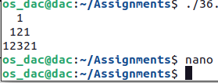

**37**

#!/bin/bash

read -p "Enter the number " n

r=0

rev=0

while(($n>0))

do

r=$((n%10))

rev=$((rev*10+r))

n=$((n/10))

done

echo "reverse is $rev"

**38.**

#!/bin/bash

read -p "Enter the number " n

r=0

rev=0

temp=$n

while(($n>0))

do

r=$((n%10))

rev=$((rev*10+r))

n=$((n/10))

done

if(($temp==$rev))

then

echo " $temp is palindrome number"

fi



**39.**

#!/bin/bash

for((i=100;i<200;i++))

do

if(($i%9==0))

then

echo -n "$i "

sum=$((sum+i))

fi

done

echo

echo "sum is $sum"



1. .Write a Shell Script to display the pyramid pattern using the alphabet.

A

A B A

A B C B A

A B C D C B A

#!/bin/bash

echo "Enter the number of rows: " read rows

# outer loop to handle number of rows for((i=1;i<=rows;i++))

do

# inner loop to handle spaces for((j=i;j<=rows;j++))

do

echo -ne " " done

# inner loop to handle alphabets in ascending order for((j=1;j<=i;j++))

do

echo -ne "$(printf \\$(printf '03%o' $((j+64)))) " done

# inner loop to handle alphabets in descending order for((j=i-1;j>=1;j--))

do

echo -ne "$(printf \\$(printf '03%o' $((j+64)))) " done

# print new line echo

done

